Project Development Phase
Model Performance Test
Date | 06-10-26
Team ID | 23KD1A4230
Project Name | Metro Ticket Generating System in ServiceNow
Maximum Marks

Model Performance Testing:
S.No. | Parameter | Values | Screenshot
1 | System Summary | Metro Ticket Generating System developed natively on ServiceNow. Commuters use the mobile Service Portal to select source and destination stations, dynamically calculate travel fares, generate secure digital QR tickets, and receive automated booking confirmations via email. | 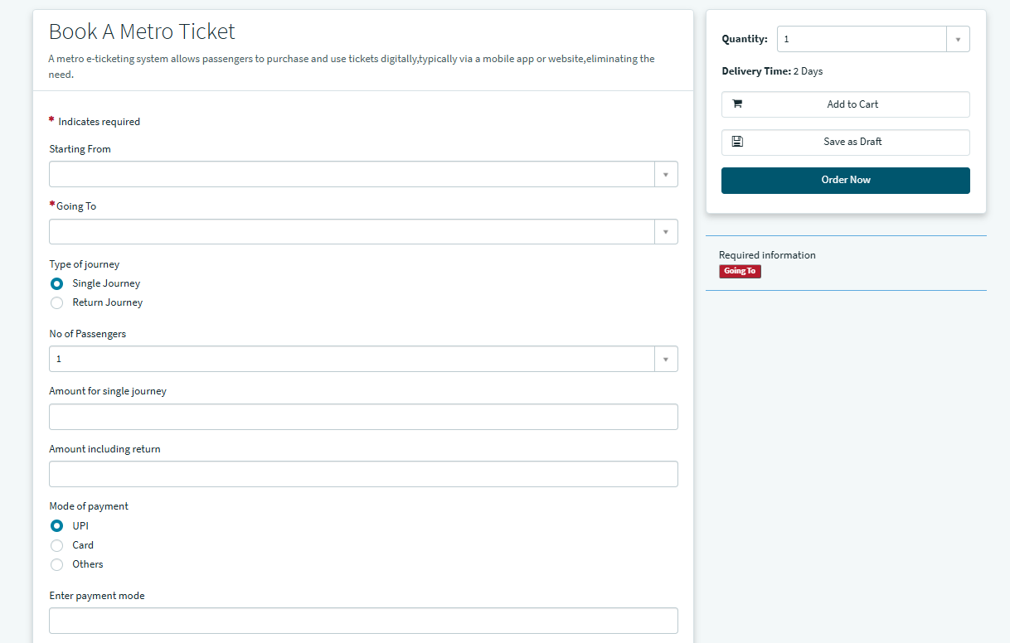
2 | Functional Accuracy | • Fare Calculation Accuracy -100%  • QR Ticket Generation Accuracy - 100%  • Backend Record (RITM) Creation -100%  • Notification Delivery Success Rate - 98% | 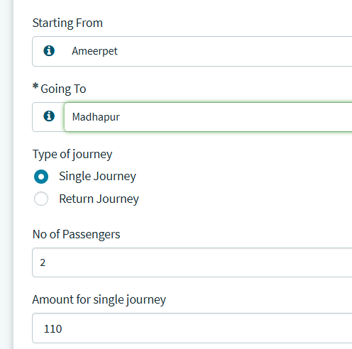
3 | Performance Testing | • Catalog Form Load Time - Less than 2 seconds  • GlideAjax Fare Retrieval - Less than 1 second  • Automated Ticket Generation Time - Less than 3 seconds  • Admin Dashboard Render Time - Less than 4 seconds | 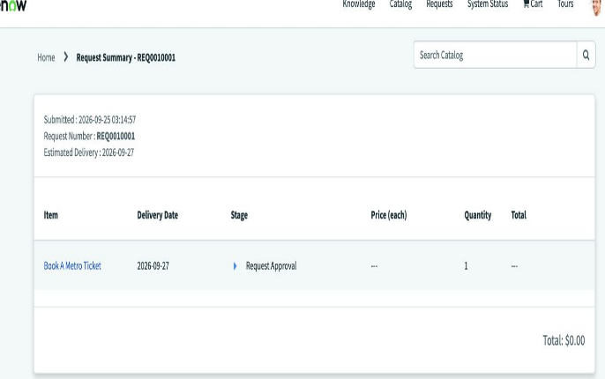
4 | User Acceptance Testing | 100% of UAT participants successfully completed the end-to-end booking journey, including fare calculation, QR ticket generation, and email receipt, without encountering any critical blocker issues. | 